Canberra Times

Putting a touch of magic into everyday reality

By Sasha Grishin
14 September 2018 — 12:00am

Kirrily Hammond: Lowlands paintings. Beaver Galleries, 81 Denison Street, Deakin. Until September 23.

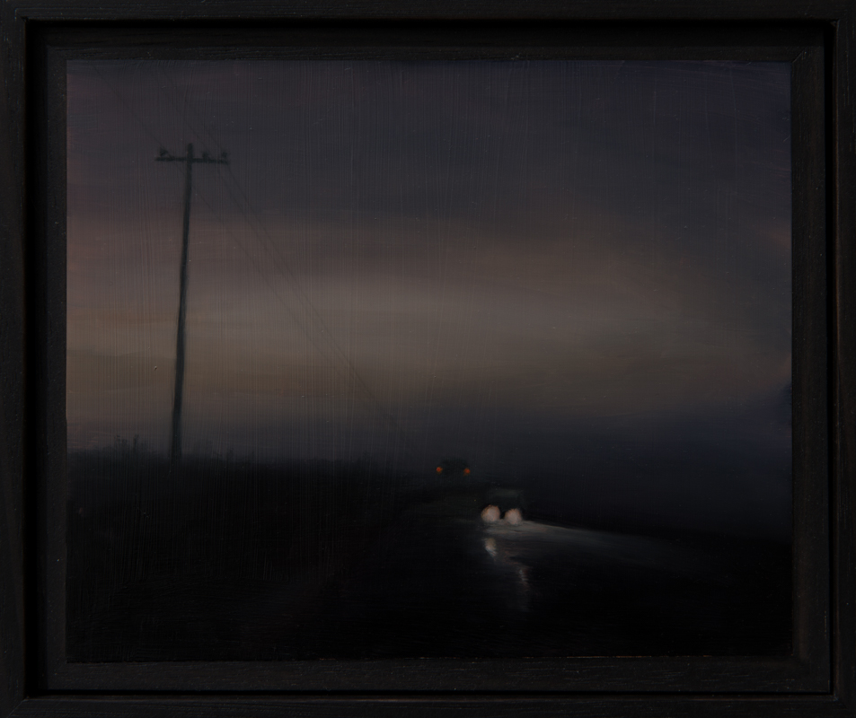
Kirrily Hammond, Gloam, 2018, in Lowlands at Beaver Galleries.

Kirrily Hammond employs the language of high romanticism with touches of the sublime to tackle the subject matter of the suburban reality. Working in oils on small panels of copper plate, she creates gem-like tableaux, which shimmer on the gallery walls and that have attracted an appreciative Canberra audience with the exhibition virtually selling out on the opening night.

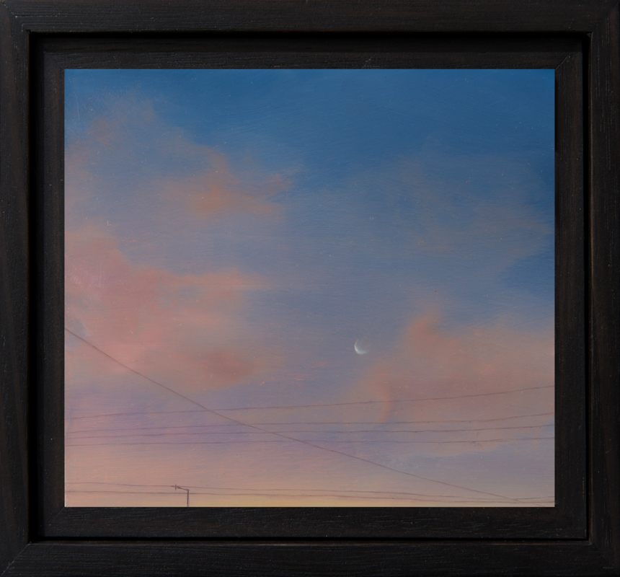

Kirrily Hammond, Moon, 2018, in Lowlands at Beaver Galleries.

Her paintings closely mimic a photographic reality, but Hammond seems not drawn to delete warts and all of the scenes to which she bears witness. A lovely painting at the show titled Moon depicts the traces of a faint moon cast against a pink, glowing evening sky. It immediately brings to mind parallels with the work of the 19th-century German romantic landscape painter Caspar David Friedrich, where I would anticipate seeing heavily clad figures staring into infinity or the work of Australian painters such as David Davies or Arthur Streeton celebrating the majesty of nature. Instead, in Hammond’s small painting, we catch the outlines of telegraph poles and power lines that remind us that the moon rises not only over the spirit of God in nature but also over suburbia.
Hammond works on a small, rather than miniature scale, with the largest copper panels measuring 20 centimetres by 24.2cm and the rest 12x9cm. This forces the viewer into an intimate engagement with the work instead of allowing for a contemplative distance. If part of her exhibition tugs towards Friedrich and that European tradition of the sublime, the rest looks to a source closer to home, that of Clarice Beckett.

Beckett was a tonal painter who was attracted to the ideas of Max Meldrum. She spent much of her time nursing her parents at their home in Beaumaris in bayside suburban Melbourne. Popular legend has it that the only time she had to paint was at dawn or at dusk when she would set off with her painting trolley to record the mists and fogs of Beaumaris with traffic struggling through the gloom.
Hammond in a painting such as Gloam arrives at a formula very similar to that of Beckett, wherein a misty twilight in a suburban street scene with the tall verticals of the telegraph poles, car headlights fight to illuminate the small arc of light. The use of an archaic word for the title further heightens connotations of something belonging to the past.

Hammond has been exhibiting for over two decades and has established a reputation as an artist who manages to transfigure a common everyday reality into something that has been touched with a bit of magic.

